Ayush Goyal
190905522 CSE D 62

Computer Networks Week 7: Lab 11: Design of VLANs using GNS3

Lab Excercises:

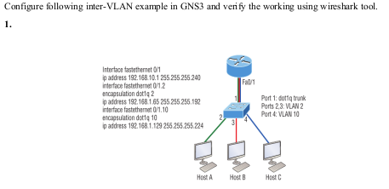

My network( i have used 4 Pcs and have kept 2 Pcs in each network):

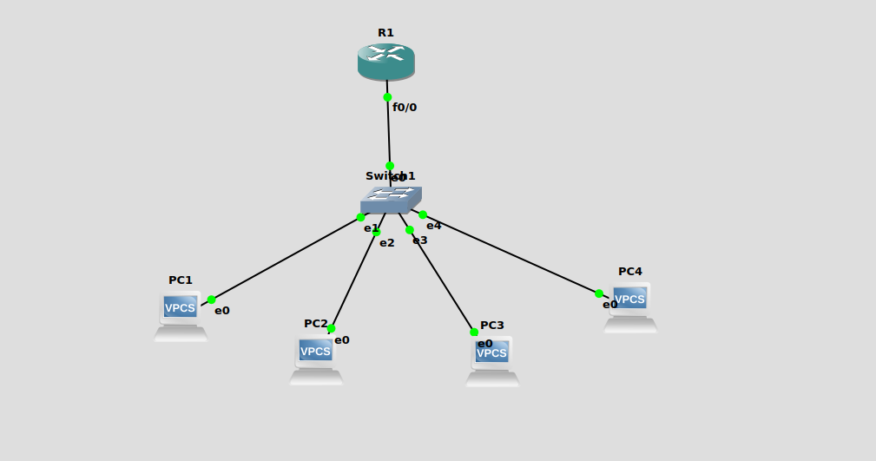

To accomodate the switch communicating between two VLANs, we need to configure the ports with which VLAN ID they will be serving andwhich protocol they will be following.We assign VLAN1 to the port which connects to the router (trunk) and configure it to dot1q protocol.

We create two more ports for VLAN2 for PC1 and PC2 and configure it to access.Similarly, two more for VLAN3 for PC3 and PC4, with access.A trunk is a connection which acts as two or more seperate connections via the same port.To accomodate for the router communicating between two VLANs, the trunk connection needs to have two seperate IP-Addresses (one for each VLAN). The interface f0/0 of the router itself does not contain any of these IP-Addresses networks but their sub-interfaces do.By running the command encapsulation dot1q 2, we are configuring the router to use the IEEE 802.1q protocol for cross VLAN communication with the VLAN Id for this interface as 2.

The switch has been configured as follows:

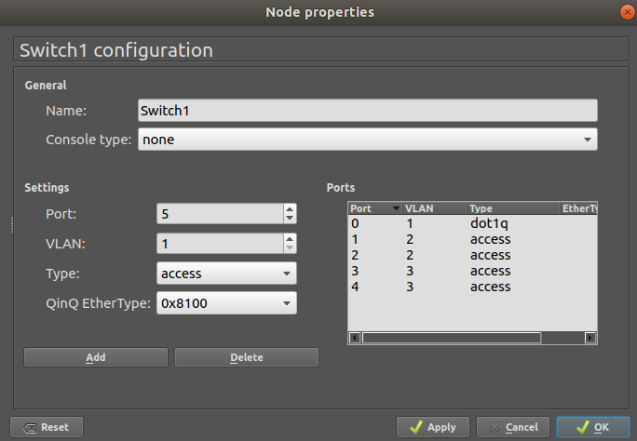

Configuring the router R1 to have sub interfaces for acccepting multiple VLAN packets on 1 interface itself.

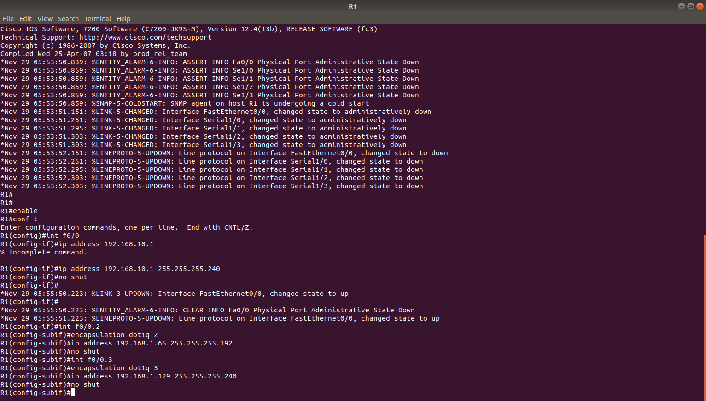

Configuring PC1, PC2 and PC3, PC4 by giving the appropriate IP addresses and default gateways.
PC1 and PC2 are in VLAN 2 whereas PC3 and PC4 is in VLAN 3.

PC1:

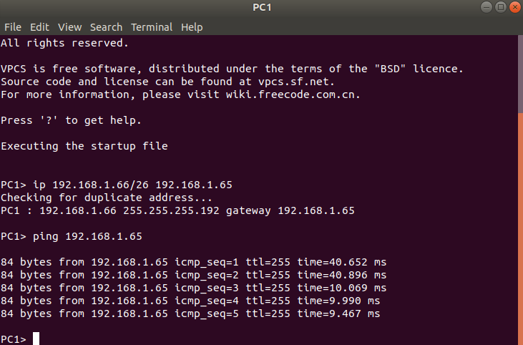
PC2:

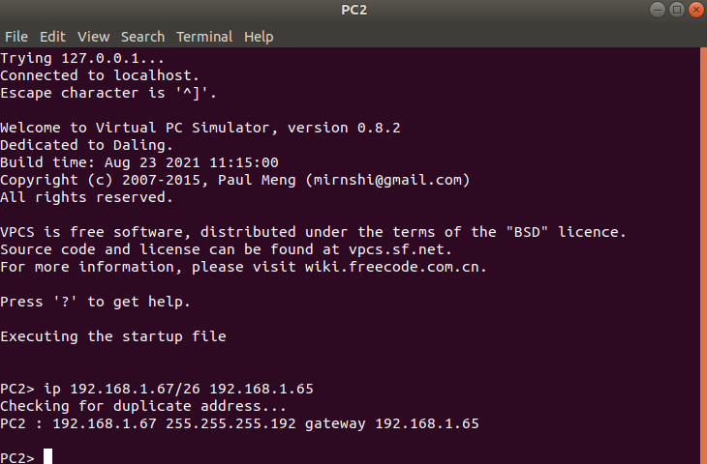

PC3:

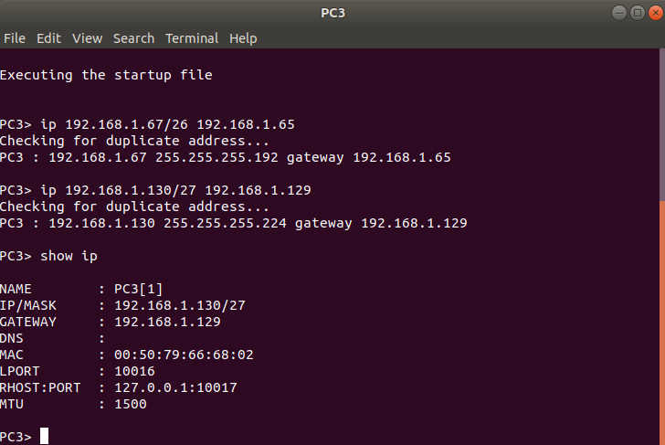

PC4:

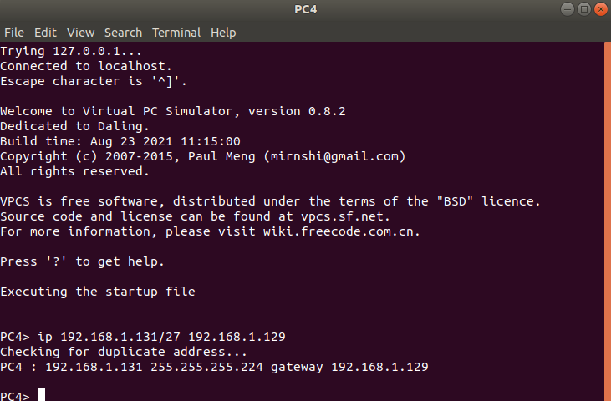

Successfully pinging the default gateway for PC1(in above PC1 screenshot) and this one pinging PC2 and PC3 from VLAN id 2 and 3 network respectively:

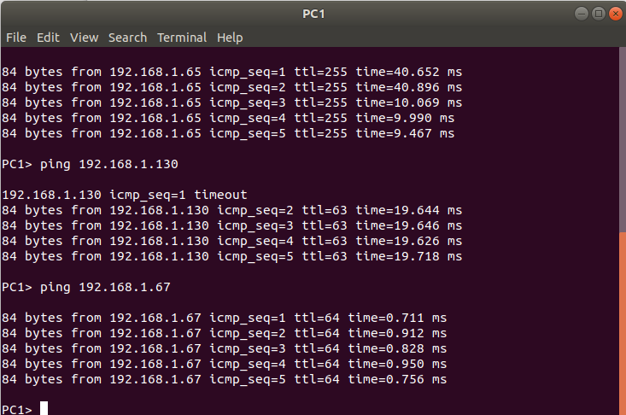

Wireshark capture of pinging PC3 from PC1 (in network 3 from network 2):

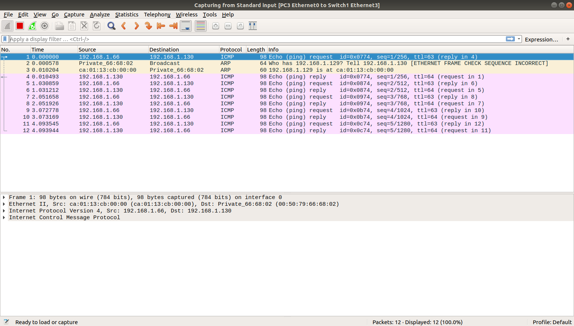

2. Configure following inter-VLAN example in GNS3 and verify the working using wireshark tool.

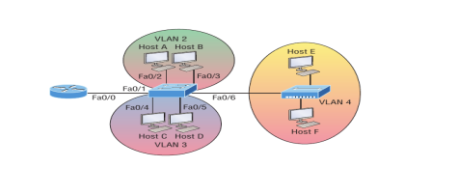

My network:

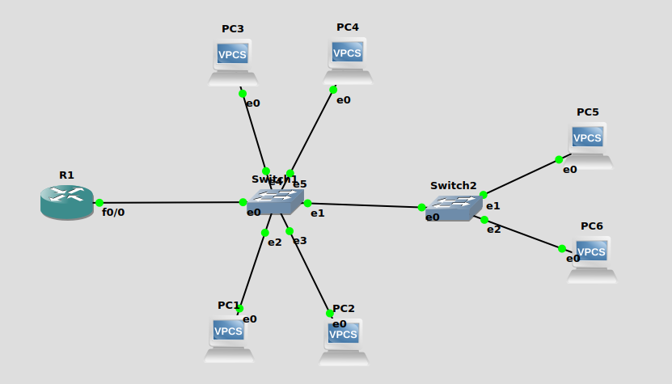

The switches have been configures as shown in the diagrams below:

Switch 1:

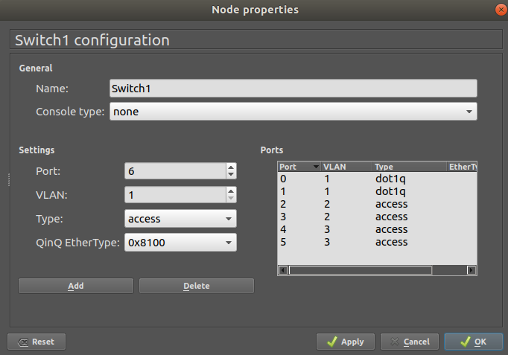

Switch 2:

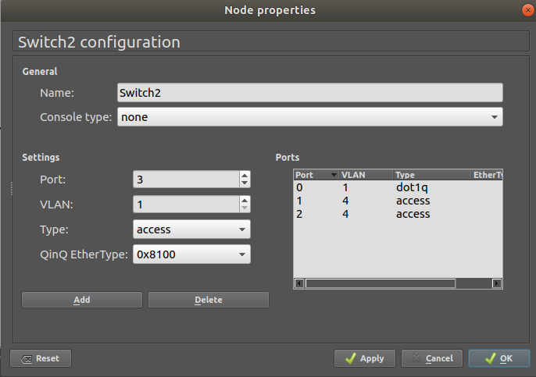

We make the connection from the first switch to the next switch a trunk.

Then we configure the router R1 as shown in the screenshot below:

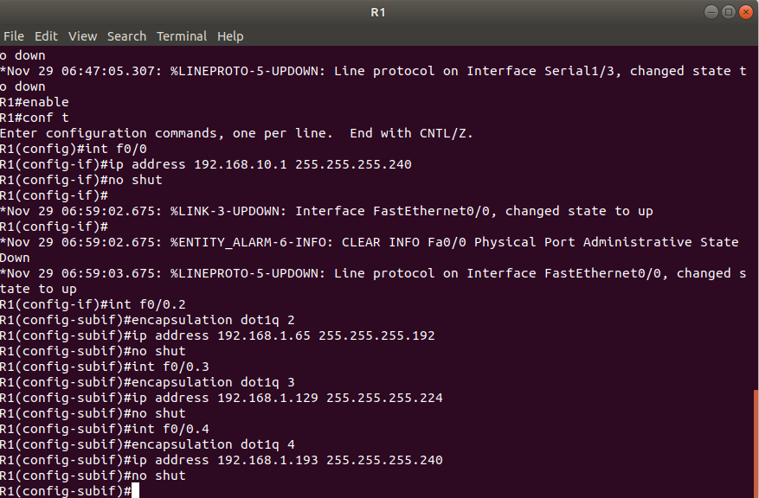

Here, there are 2 trunk ports present :
We connect the 2 switches using the port 1 in Switch1 and port 0 in Switch2.
This connection acts as the trunk line to allow Switch2’s traffic to reach the router located on Switch1.
Next we configure the router’s port f0/0 to be a trunk port for the 2 VLANs.

Then we configure all Pcs(1-6) withthe given IP and masks as shown below:

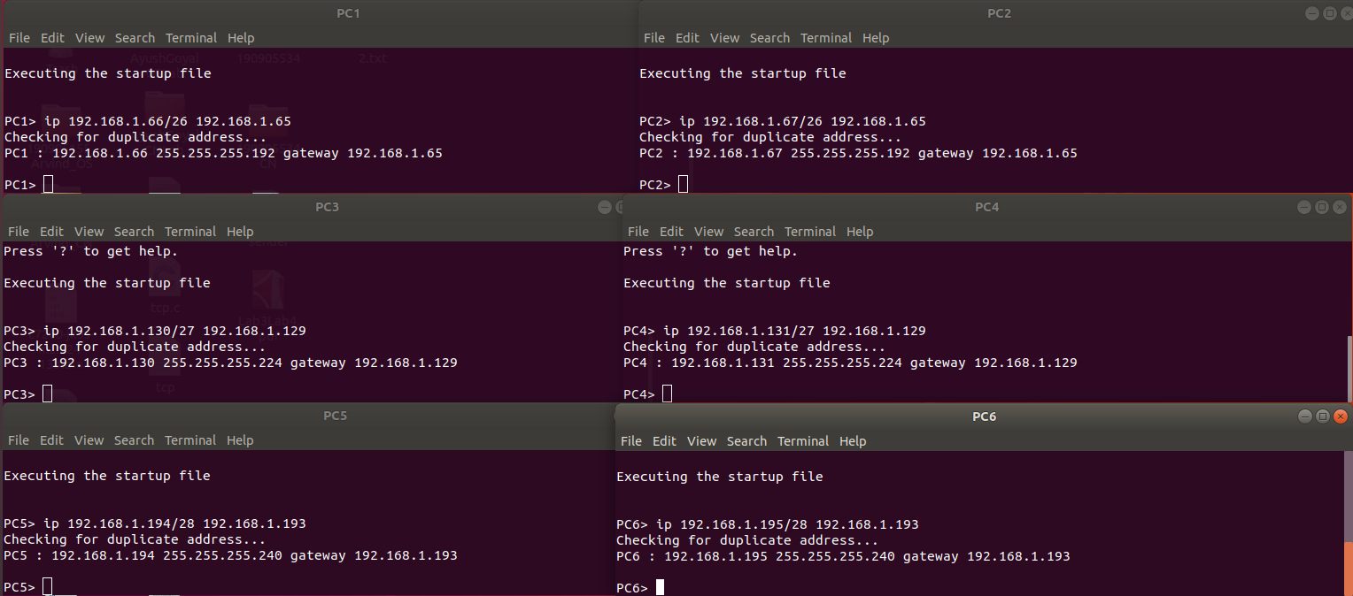

Now, pinging the default gateway from PC1 successfully:

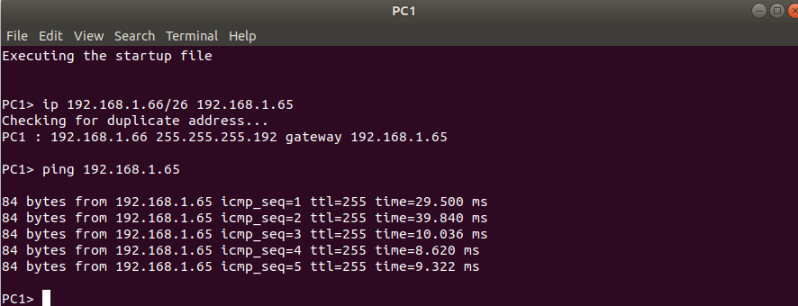

Pinging PC3 and PC4 in VLAN id 3 from PC1 in VLAN id2:

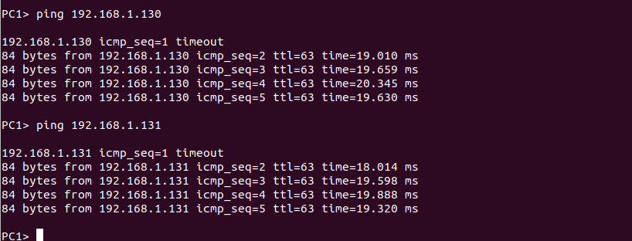

Pinging PC5 and PC6 in VLAN id 4 from PC1 in VLAN id2:

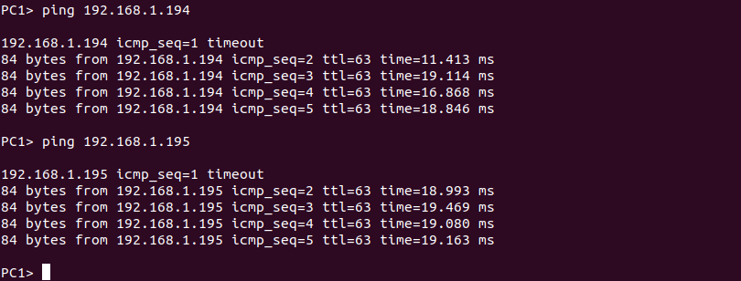
Pinging default gateway in PC6 in VLAN4 and then pinging PC1 in VLAN2:

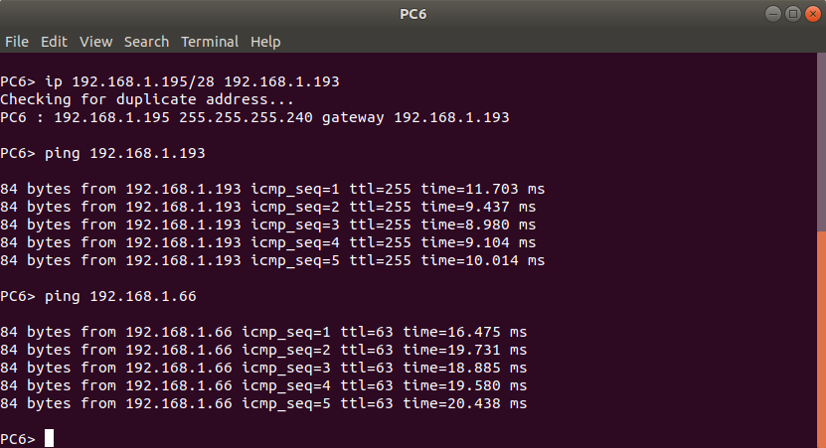

Wireshark capture for ping from PC6(VLAN4) to PC1(VLAN2):

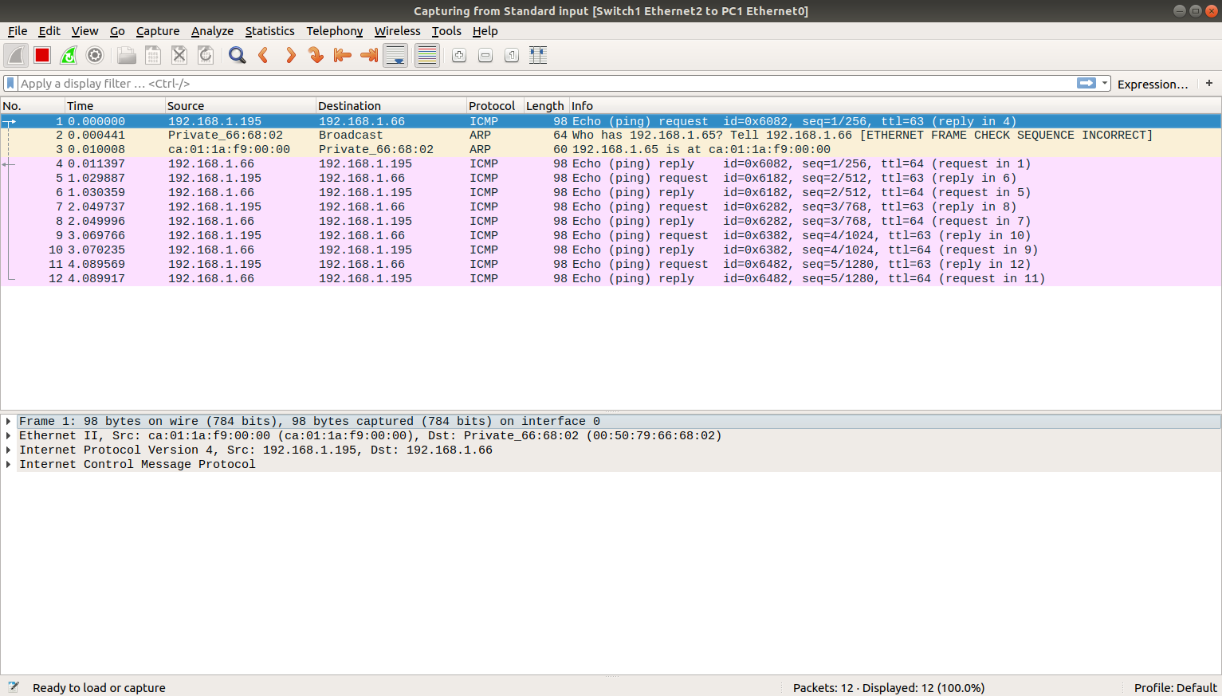

THE END

Computer Networks Week 7: Lab 12: Study of dynamic routing protocols using GNS3

Lab Excercise:

The conection is as shown below:

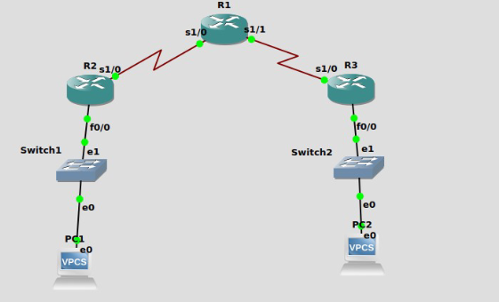

Firstly i would be configuring the router R1:

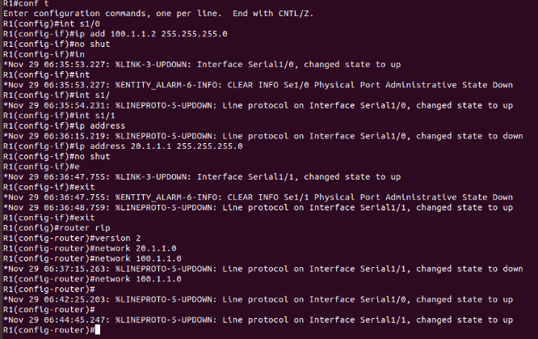
Then i would be configuring the second router as shown in the figure namely router R2:

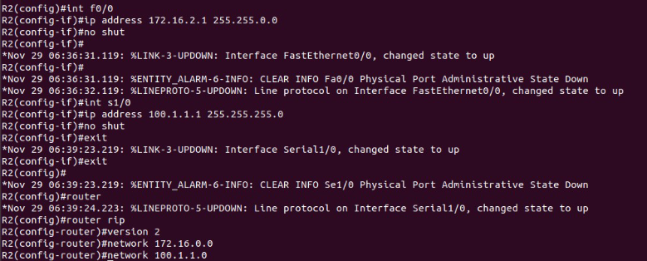
Then i would be configuring the third router as shown in the figure namely router R3:

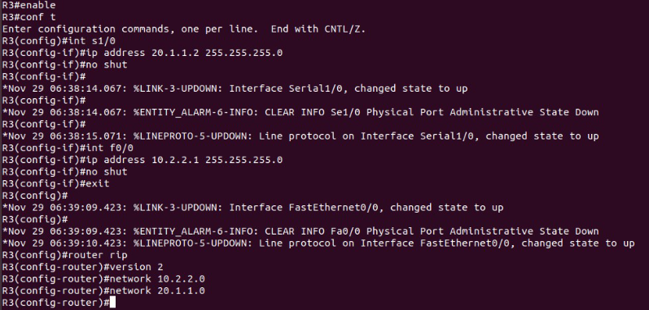

Then i would be asssigning IP addresses and default gateways for PC1 and PC2:

PC1:
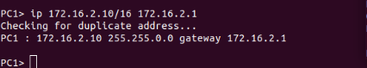

PC2:
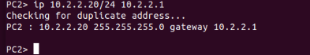

Then i am pinging to the default gateway(172.16.2.1) and then to PC2(10.2.2.20) from PC1 as shown in the screenshot below:

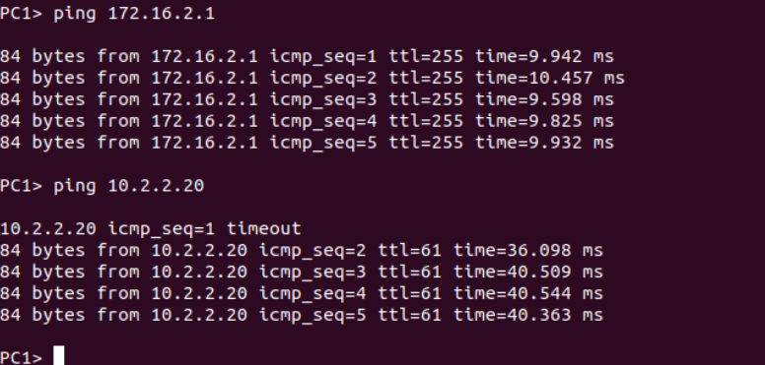

Then when we run the “show ip route” command for Router 1, we see the neighbouring networks for router R1 that we have connected - 20.1.1.0 and 100.1.1.0 as shown below:

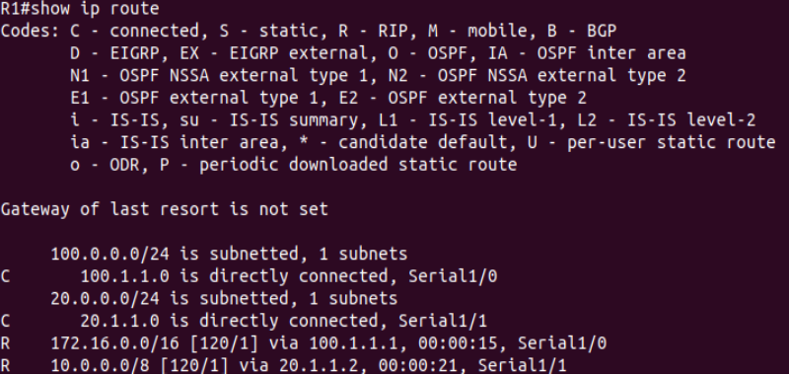

Similarly, when we run the “show ip route” command for Router 2, we see the neighbouring networksfor router R2 that we have connected - 172.16.0.0 and 100.1.1.0

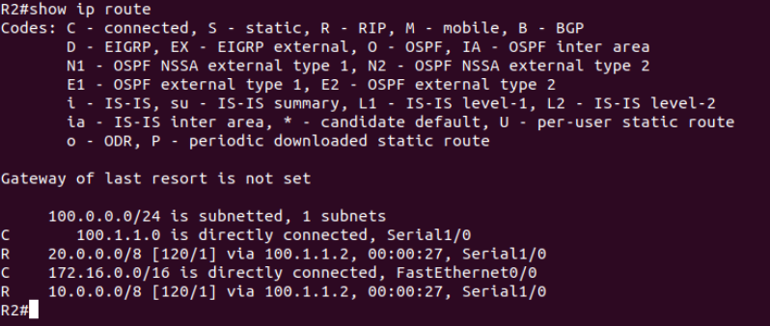

And then when we run the “show ip route” command for Router 3, we see the neighbouring networks for router R3 that we have connected - 20.1.1.0 and 10.2.2.0 as shown below:

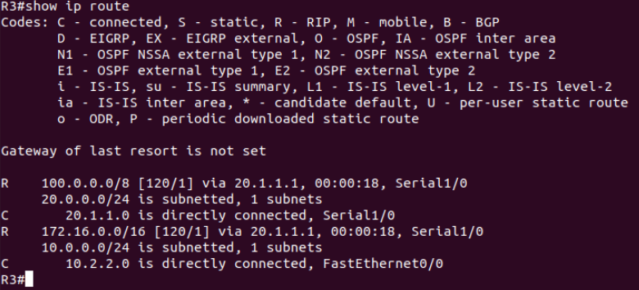

On executing the “show ip protocol” command for Router 1 we see that the routing protocol is “rip”:

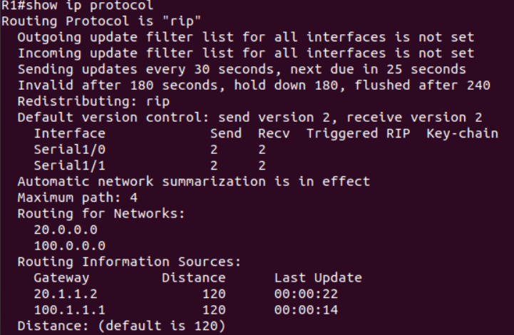

And finally, when we execute the “show ip rip database” command for Router 1 we see information about routes in the Routing Information Base as displayed in the screesnhot below:

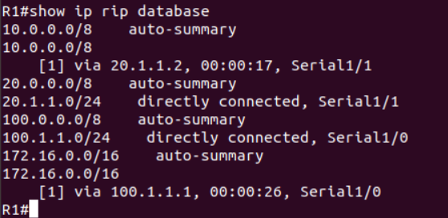

THE END

